

**Advanced Databases Assignment**

**Module Title: Advanced Databases for MSc Module**

**CRN Code: 33386, 34902**

**Programme Code(s): G430 M0052**

**Assessor(s): Prof. Mo Saraee,**

**Dr Charith Silva**

**Student Name: DAKSHINAMURTHY SAI NANDAN PUJYAM**

**Student Id: @00655520**

Table of Contents

1. TASK1 3

1.1 ABSTRACT 3

1.2 INTRODUCTION 3

1.3 RELATIONAL SCHEMA 3

1.4 DESIGN RATIONALE 4

1.5 DESIGN CONSERIDATIONS 4

1.6 T – SQL STATEMENT 4

1.7 REPORT DESIGN 12

1.8 DATABASE SECURITY 14

1.9 DATABASE BACKUP AND RESTORE 18

1.10 Data Science/Business Intelligence Techniques 20

1.11 Data Privacy, Ethical and legal issue 20

1.12 CONCLUSION 20

2 TASK 2 21

2.1 ABSTRACT 21

2.2 INTRODUCTION 21

2.3 DESIGN RATIONALE 21

2.4 DESIGN CONSIDERATIONS 21

2.5 T SQL STATEMENTS 21

2.6 REPORT DESIGN 26

2.7 BUSINESS INTELLIGENCE TECHNIQUES 27

2.8 DATA PRIVACY, ETHICAL AND LEGAL ISSUES 27

2.9 CONCLUSION 27

3 TASK 3 28

3.1 ABSTRACT 28

3.2 INTRODUCTION 28

3.3 DESIGN RATIONALE 28

3.4 T-SQL STATEMENTS 28

3.5 REPORT DESIGN 30

3.5.1 QGIS REPORTS 31

3.6 DATA SCIENCE/BUSINESS INTELLIGENCE TECHNIQUES 34

3.7 DATA PRIVACY, ETHICAL AND LEGAL ISSUES 34

3.8 CONCLUSION 34

4 REFERENCES 35

# TASK1

## ABSTRACT

Our main aim to do this task is to create a child wellbeing monitor to analyse child poverty data. Here we have the data from 4 low-income countries data Ethiopia, India, Peru& Vietnam, we now process the data from these countries and generate some reports based on some parameters which are useful to analyse child poverty in all these countries.

## INTRODUCTION

The Young Lives study is designed to follow the lives children from four different countries Ethiopia, India, Peru & Vietnam over fifteen years, The survey is conducted every three to four years. In the first round of the Young Lives study, two groups of one-year-olds and five-year-olds were surveyed in each of the countries. Round 2 of the study returned to the same 5- and 12-year-olds who participated in Round 1. Round 3 surveyed the same children again at ages 7-8 years and 14-15 years, round 4 surveyed them at age 12, and Round 5 surveyed them at age 15 and age 22 years old.

## RELATIONAL SCHEMA

The schema diagram gives us a clear view that all the tables are related to one single table.

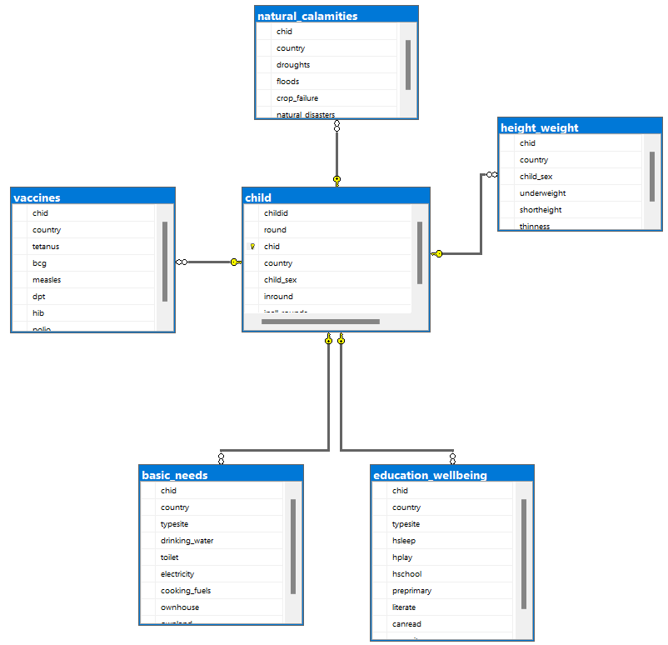

## DESIGN RATIONALE

The data we took from young lives is not suitable to generate results, we need to study their reports to get an idea about the data. Now we need to convert that raw data to a meaningful one for generating reports out of it.

## DESIGN CONSERIDATIONS

First, we load the meta data into our database after that we create tables required, all these tables are related with primary and foreign keys. After all tables are created, we insert data into that tables using stored procedures to reduce code repetition.

## T – SQL STATEMENT

Here we created 7 tables the first is the child table which contains the primary key as chid the concatenation of childid and round columns, and remaining tables are related with foreign key as chid, we also added country column to categorise the data.

--creating child table

create table child(

childid varchar(30),

round int,

chid varchar(30),

country varchar(50),

child_sex varchar(100),

inround varchar(100),

inall_rounds varchar(100)

PRIMARY KEY(chid)

)

--creating child habbits table

create table child_avgbmi(

chid varchar(30),

country varchar(50),

child_height varchar(50),

child_weight varchar(100),

child_bmi varchar(100)

constraint FK_habbits FOREIGN KEY(chid) references child

)

--creating table for child height & weight for age

create table height_weight(

chid varchar(30),

country varchar(50),

child_sex varchar(100),

underweight varchar(100),

shortheight varchar(100),

thinness varchar(100),

constraint FK_height_weight FOREIGN KEY(chid) references child

)

--creating table for child vaccines

create table vaccines (

chid varchar(30),

country varchar(50),

tetanus varchar(100),

bcg varchar(100),

measles varchar(100),

dpt varchar(100),

hib varchar(100),

polio varchar(100),

constraint FK_vaccines FOREIGN KEY(chid) references child

)

--creating table for childs basic needs

create table basic_needs (

chid varchar(30),

country varchar(50),

typesite varchar(100),

drinking_water varchar(100),

toilet varchar(100),

electricity varchar(100),

cooking_fuels varchar(100),

ownhouse varchar(100),

ownland varchar(100),

constraint FK_basic_needs FOREIGN KEY(chid) references child

)

--creating table for natural calamities

create table natural_calamities (

chid varchar(30),

country varchar(50),

droughts varchar(100),

floods varchar(100),

crop_failure varchar(100),

natural_disasters varchar(100),

constraint FK_natural_calamities FOREIGN KEY(chid) references child

)

--creating table for child education and wellbeing

create table education_wellbeing(

chid varchar(30),

country varchar(50),

typesite varchar(100),

hsleep varchar(100),

hplay varchar(100),

hschool varchar(100),

preprimary varchar(100),

literate varchar(100),

canread varchar(100),

canwrite varchar(100),

constraint FK_education_wellbeing FOREIGN KEY(chid) references child

)

Below are the stored procedures used for inserting data into the tables we created.

These stored procedures used to reduce the code repeatability and increases the reusability of the code, first we give a name to the procedure and we declare the parameters to be passed in it and data type of the parameter and begin it and we need to declare inner parameter and use set to write your queries inside the inner parameter and execute it. Once the procedure is created we can execute the procedure using its name and passing the parameters needed.

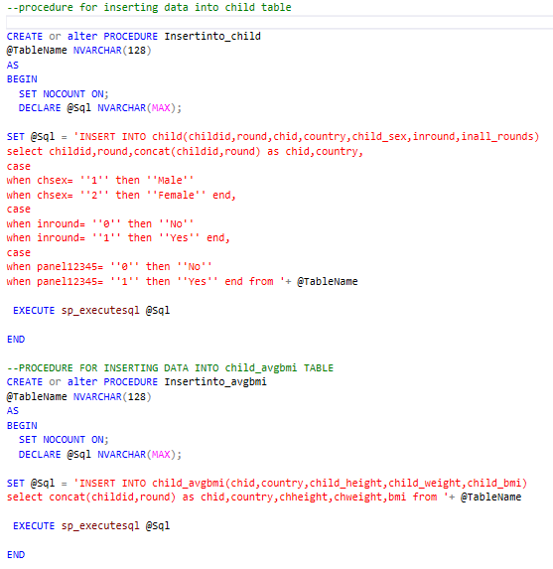

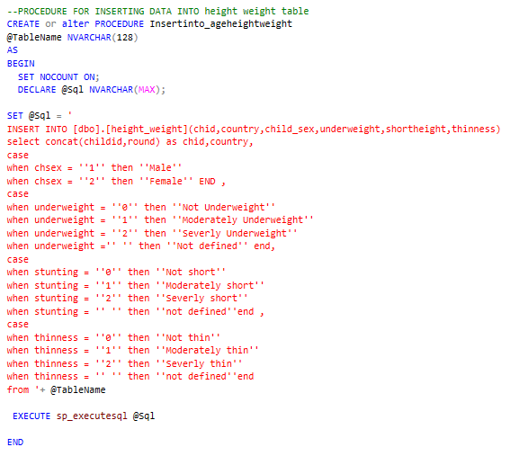

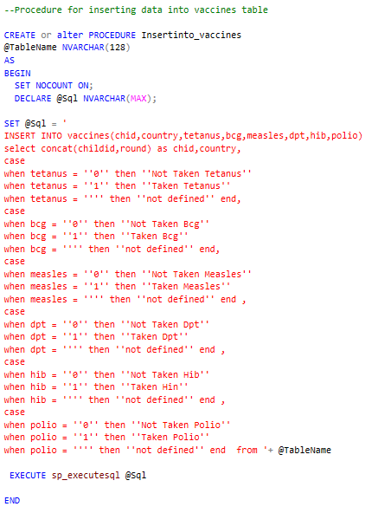

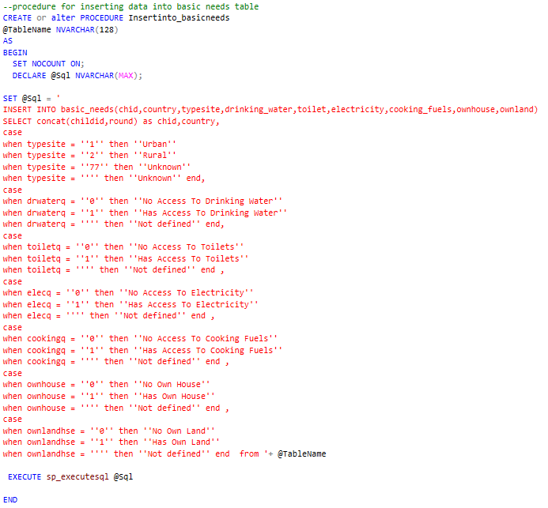

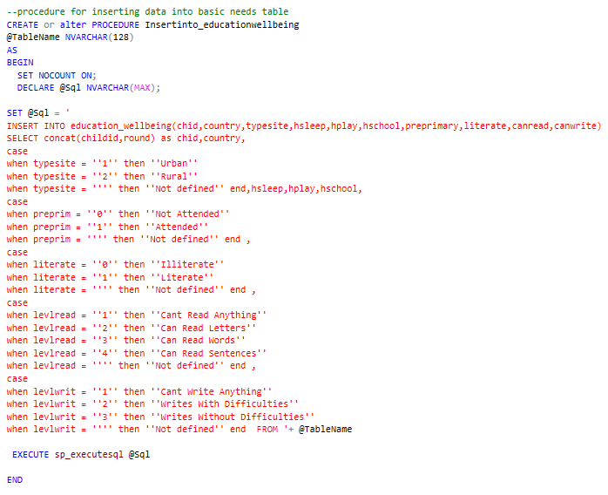

Using the stored procedures we created, now we are calling those procedures to insert data into the tables.

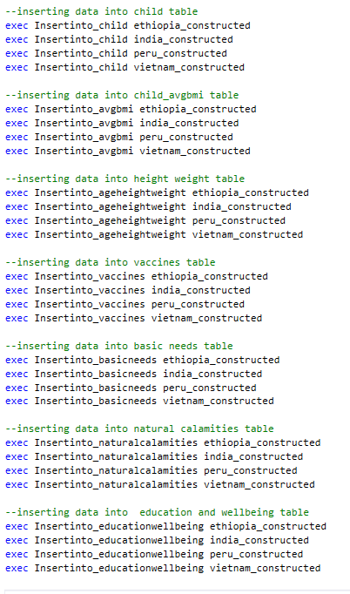

Now we created views to generate reports out of the tables.

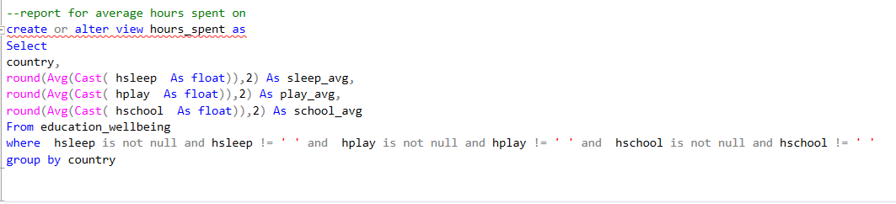

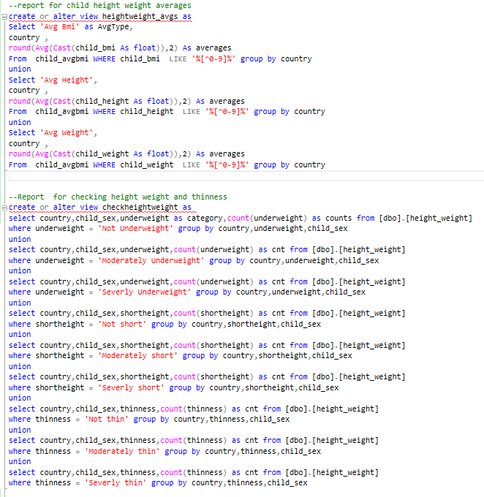

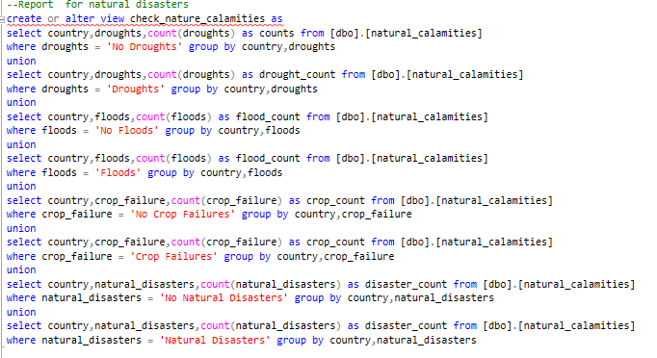

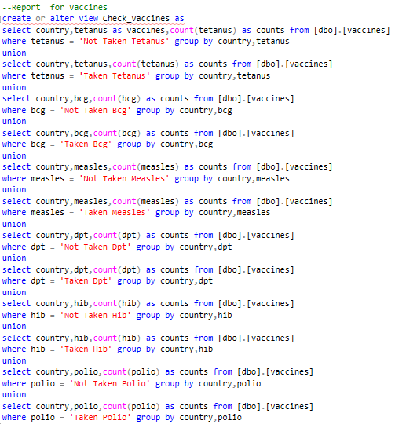

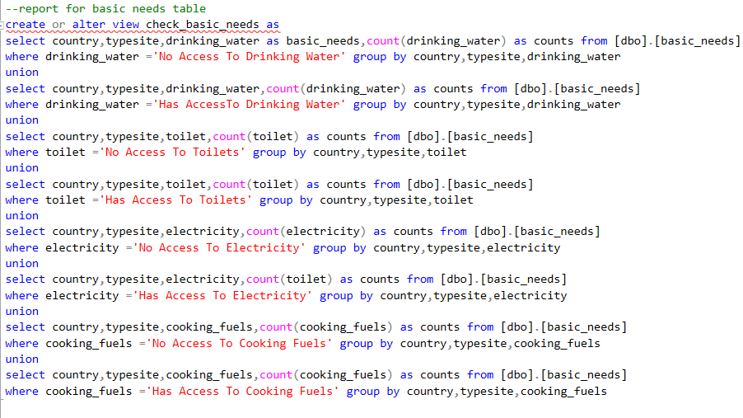

## REPORT DESIGN

Here we will use power bi tool to generate visual reports for the data we analysed.

The below chart displays country wise report height, weight and thinness for age and their counts.

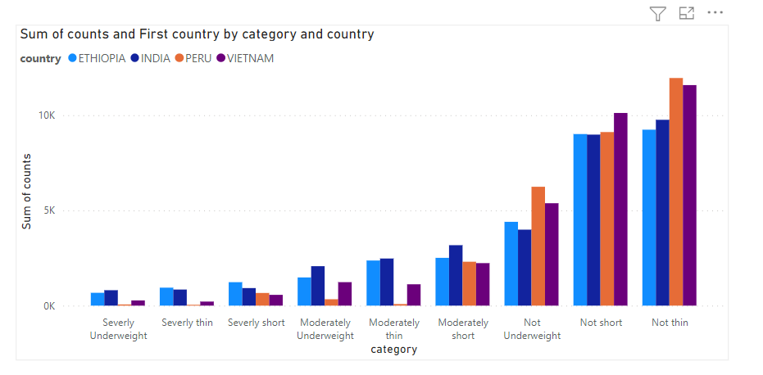

This chart displays country wise average of height, weight and bmi

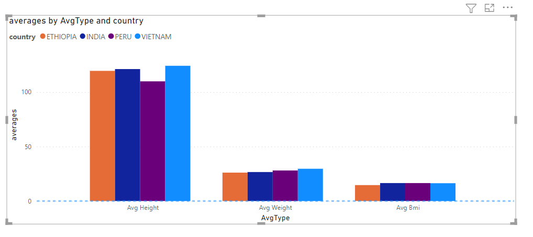

The below chart shows how many children took these vaccines stated in the report.

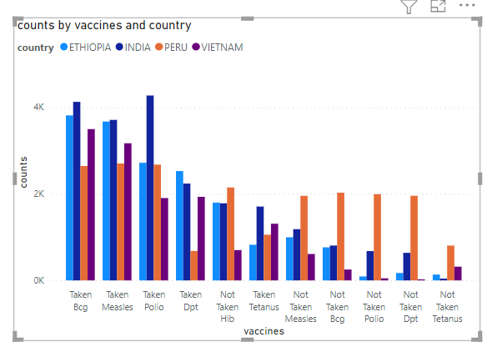

The below chart displays the report for natural calamity categories and their count

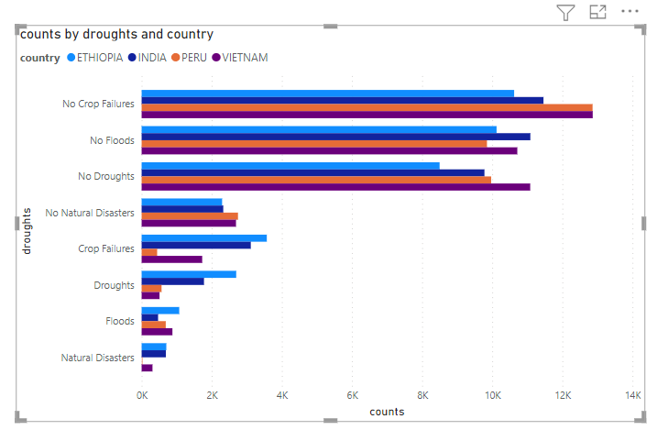

The below chart displays the report of country wise basic needs counts in Urban and rural areas.

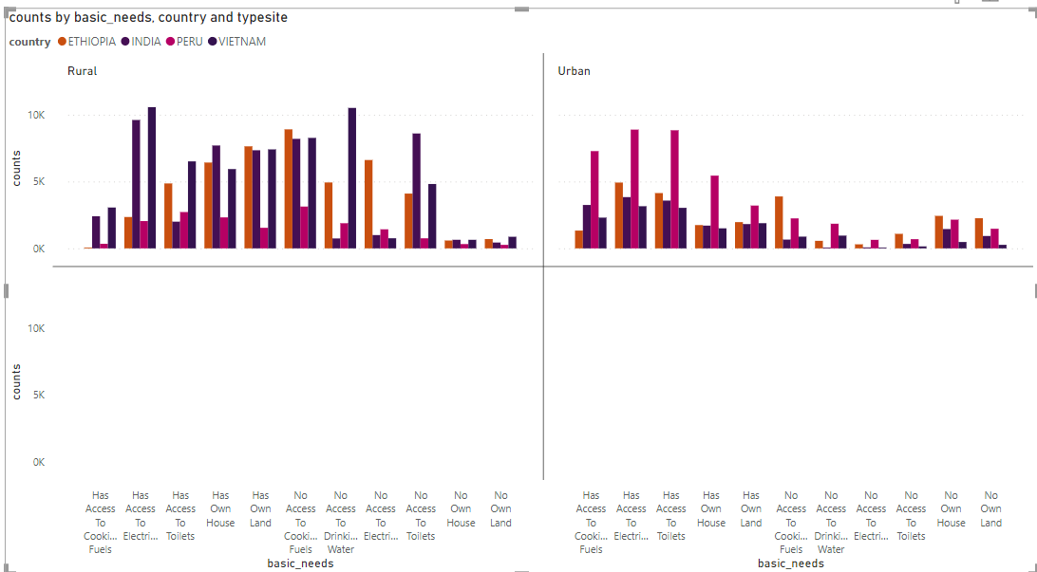

The below chart displays the report of average hours spent in sleeping, playing and in school based on the country.

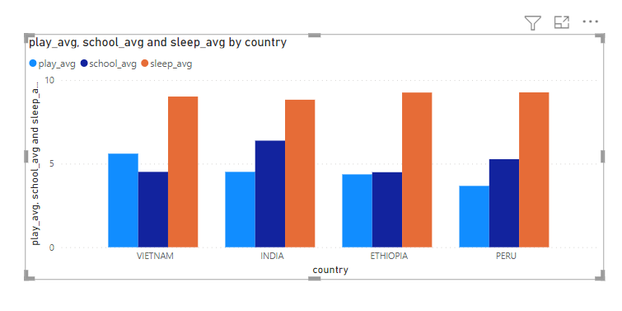

## DATABASE SECURITY

For database security first we need to create a login name and password, after that we need to create, user once the user is created then

1) select your data base

2) select security

3) select users

4) right click on your user’s name

5) select properties

After selecting in the properties window click on search near secure tables, then select the objects you wish to add and type of objects and select the required tables, views, stored procedures after that you can select type actions you like to give access to user and click ok.

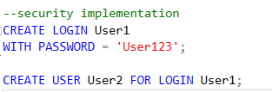

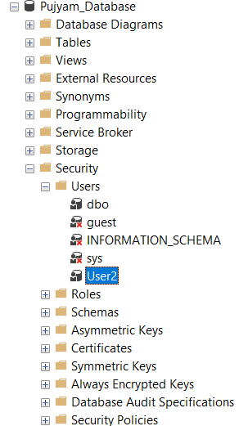

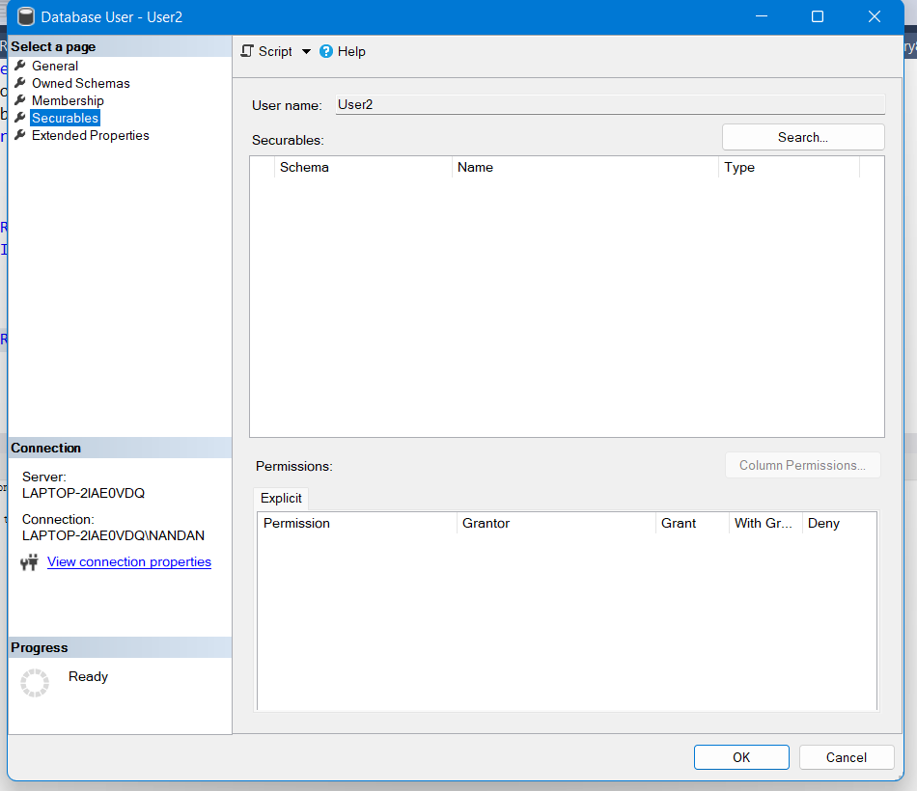

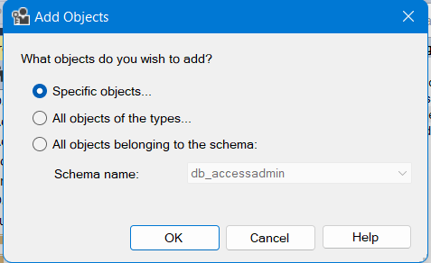

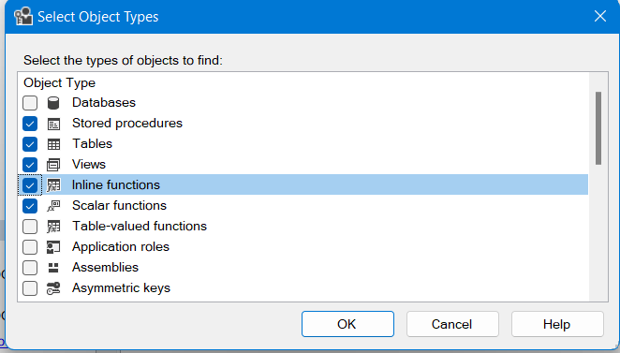

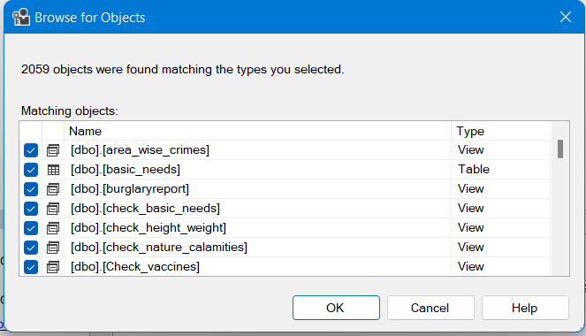

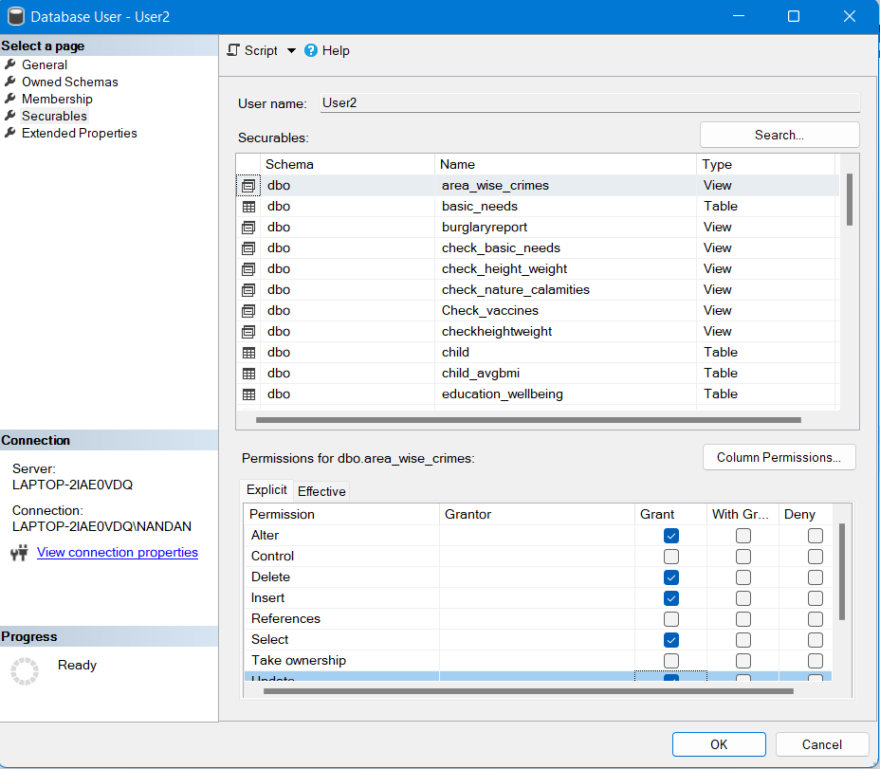

## DATABASE BACKUP AND RESTORE

In order to take backup of a database right click on database which you want to backup and in Tasks select back up option, then the backup window appears. In the window select the backup type (Here in our case full backup) and give the path where you want to keep the backup file and click ok, your back up will be created in the specified path.

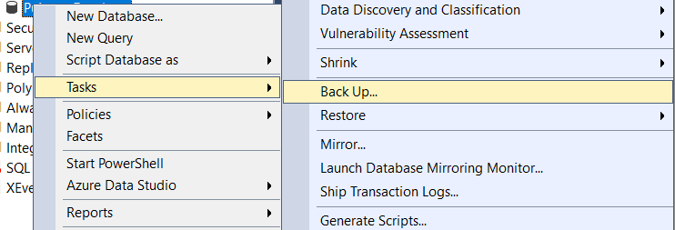

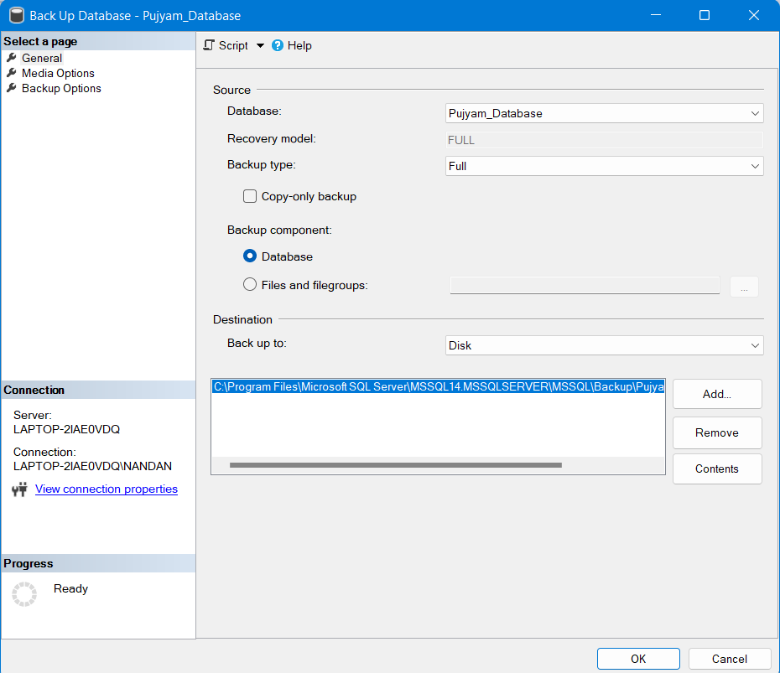

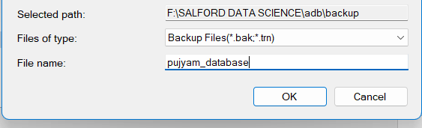

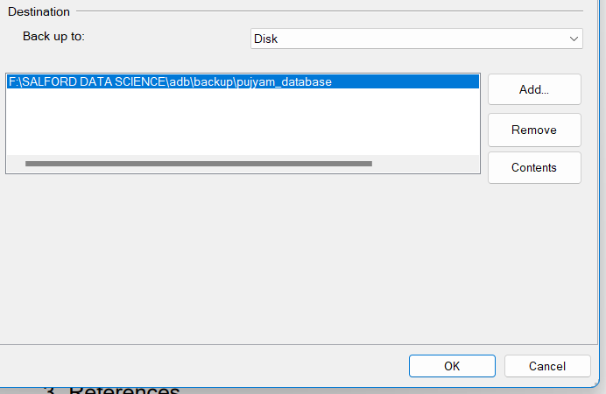

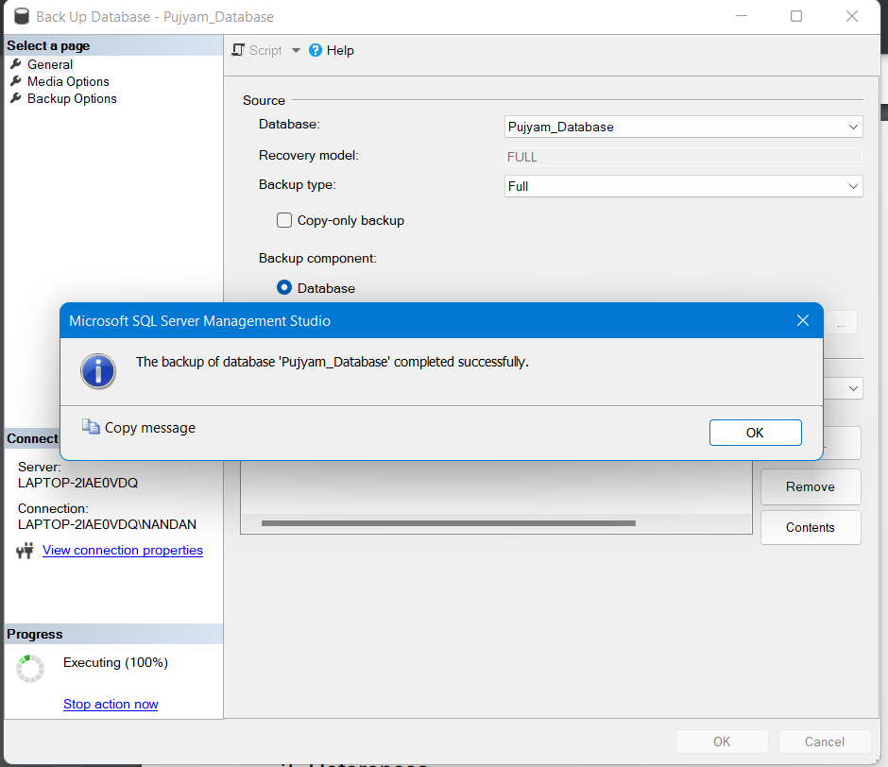

## Data Science/Business Intelligence Techniques

Using Data Science, we can predict future results using past data/predictive analysis. Business intelligence will use past data to create reports based on past data/descriptive analysis. Here we use business intelligence techniques like

Descriptive Analysis which is analysing and understanding the data, creating different queries and generating reports.

Further Analysis of report we get and visualise these reports to get a better understanding using different charts and plotting techniques.

## Data Privacy, Ethical and legal issue

Data privacy is one of the main factors to be taken into consideration when we are creating a database and exposing the data to web servers. One of the common privacy issues is SQL injection, sending unexpected data to webservers which have access to database. There are two types in SQL injection form method and browser method. This can be prevented using syntax checking and prepared statements. In our case the child poverty data contains many children details from four different countries. So it our ethical responsibility to protect their data without being theft, Neglecting the data privacy is a culpable offence.

## CONCLUSION

We took different parameters when creating tables, inserting data to tables and creating view for tables to generate reports. These reports can be used to analyse the child poverty in these countries and will help governments and charity organisations to provide assistance based on these results.

# TASK 2

## ABSTRACT

Our aim for this task is to create a simple reporting system to analysis the inequality in education sector in Vietnam.

## INTRODUCTION

For this task we take the data from young lives, school survey 2016-17 dataset and import that data to database, after importing the data we need to analyse and try to understand the data then create tables accordingly and insert data into the tables, now we create views to generate reports to the given data.

## DESIGN RATIONALE

Here the data we have contains values in 0’s and 1’s, we need to study the data dictionaries to replace those values with meaning full one’s, so that we can generate appropriate results based on the data.

## DESIGN CONSIDERATIONS

Here we are creating task2_child table and assigning a primary key to it and remaining tables are related with a foreign key.

## T SQL STATEMENTS

We created 4 tables for this task the parent table (task2-child) has the primary key as uniqueid and remaining tables are related with primary key of parent table as their foreign key.

--creating task2 student table

create table task2_child(

uniqueid varchar(100) primary key,

schoolid varchar(100),

locality varchar(100),

province varchar(100),

gender varchar(100),

age varchar(100),

)

--creating task2 child activity English table

create table task2_activityenglish (

uniqueid varchar(100),

readbook varchar(100),

watchtv varchar(100),

useinternet varchar(100),

writeemail varchar(100),

constraint fk_activityenglish foreign key(uniqueid) references task2_child

)

--creating table for child english speaking.

create table task2_speakenglish (

uniqueid varchar(100),

engmom varchar(100),

engdad varchar(100),

engsibling varchar(100),

engfriends varchar(100),

engschool varchar(100),

constraint fk_speakenglish foreign key(uniqueid) references task2_child

)

--creating table for child health conditions

create table task2_childhealth(

uniqueid varchar(100),

eyesight varchar(100),

hearingproblem varchar(100),

headaches varchar(100),

fever varchar(100),

stomachpain varchar(100),

noproblems varchar(100),

constraint fk_childhealth foreign key(uniqueid) references task2_child

)

After the tables are created , now we insert the data into those tables using insert into query to insert the data, and we are using case statements here to convert raw data to a meaningful data.

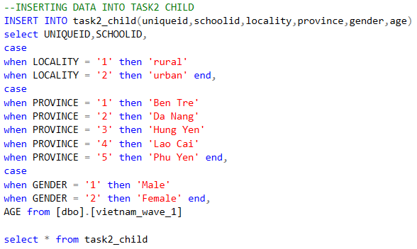

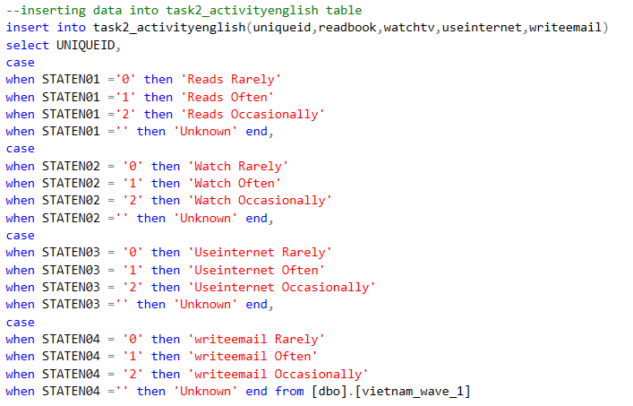

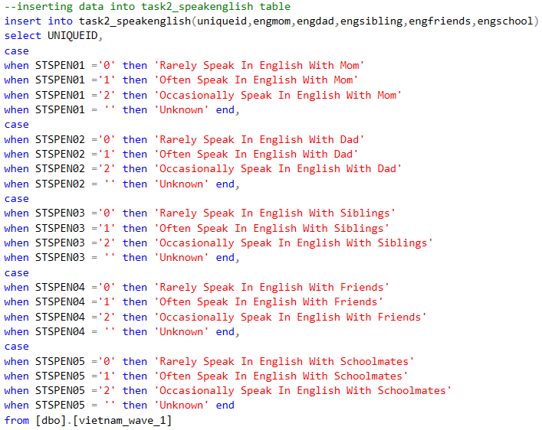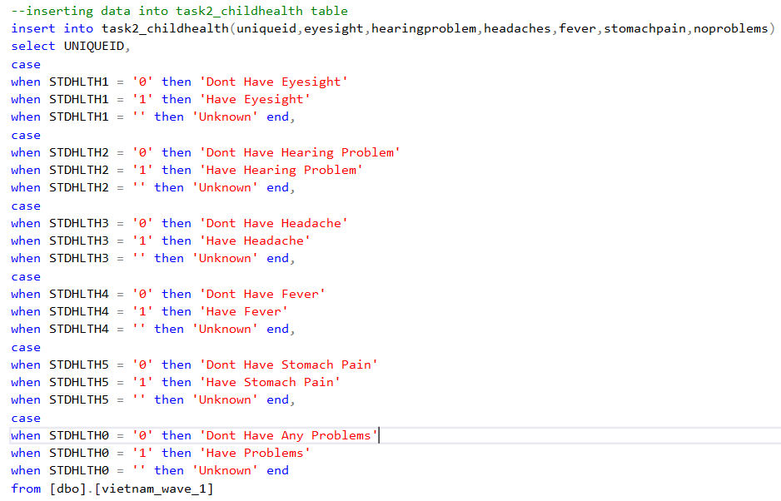

Below are the views created for generating reports.

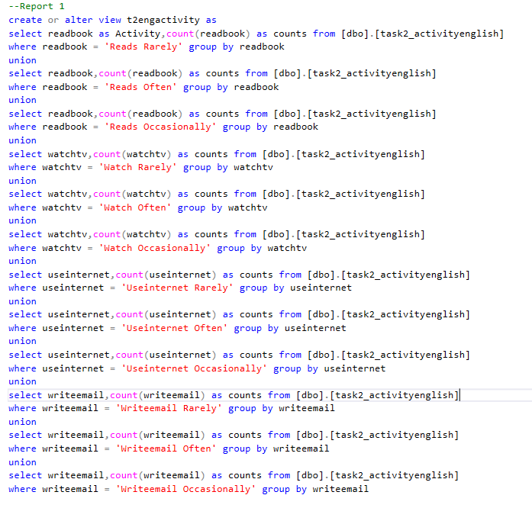

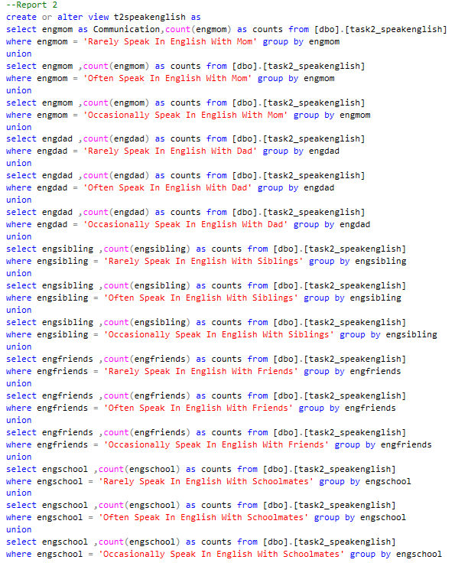

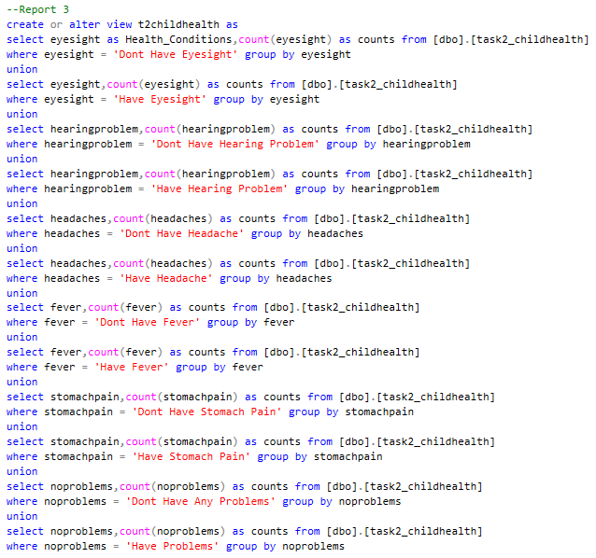

## REPORT DESIGN

For generating reports in this task we used powerbi tool to visualise the table results

The below pie chart shows the % of children who are doing the below activities in English.

These activities are categorised into

1)Rarely

2)Often

3)Occasionally

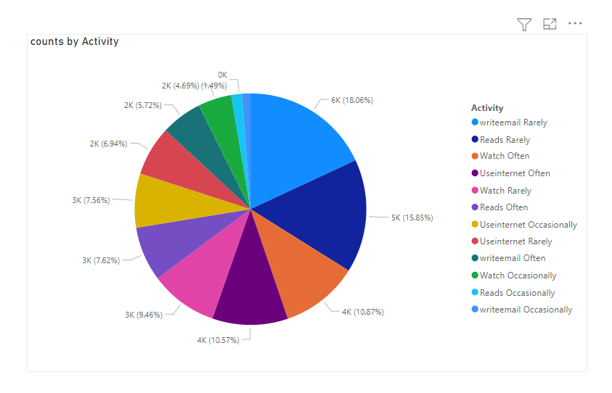

The below chart shows number of children and their health condition type

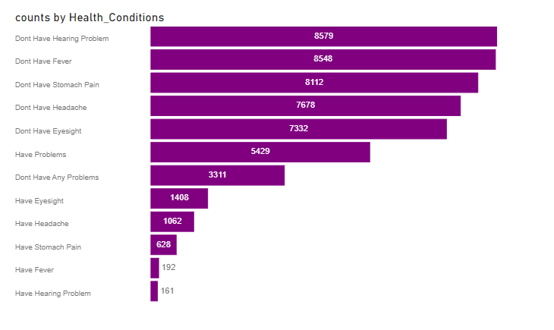

Below chart shows number of children speaks English with parents, friends and in school.

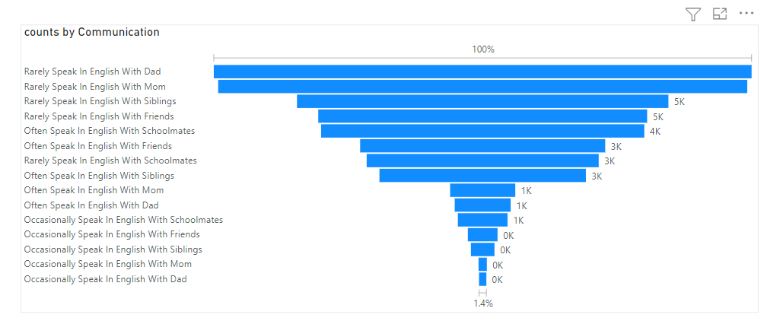

## BUSINESS INTELLIGENCE TECHNIQUES

For this task we used Powerbi business intelligence tool for visualising our data.

## DATA PRIVACY, ETHICAL AND LEGAL ISSUES

The data we used in this task is taken from young lives Vietnam study 2016-17 dataset, which contains details of children, schools, teachers from the study. So we must strive to protect their data privacy and failed to implement is culpable offence.

## CONCLUSION

After understanding the meta data we created tables and generated reports by creating views and visualisation has been done using power bi.

# TASK 3

## ABSTRACT

We take the crime data and population data and process the data to analyse crime statistics.

## INTRODUCTION

The objective of the project is to develop a reporting tool called Crime Profiler to assist in the development of computational criminology as a part of the advancement of the theory and method in criminological research. As a part of the project, you have been given a task to build a report containing Lower Layer Super Output Areas (LSOAs) wise crime report with local population data in Greater Manchester.

## DESIGN RATIONALE

Here we have the crime data and population data, we joined these two tables and we also added id column and geolocation column to plot the results in QGIS map.

## T-SQL STATEMENTS

Below are the sql queries for tables created and data insertion and creating views for generating reports

--adding id column for Manchester Street table

ALTER TABLE [manchester_street]

ADD ID INT IDENTITY;

ALTER TABLE [manchester_street]

ADD CONSTRAINT PK_Id PRIMARY KEY NONCLUSTERED (ID);

--adding geo location to Manchester Street table

alter table [dbo].[manchester_street] ADD [GeoLocation] GEOGRAPHY

UPDATE [dbo].[manchester_street]

SET [GeoLocation] = geography::Point(Latitude, Longitude, 4326)

WHERE [Longitude] IS NOT NULL

AND [Latitude] IS NOT NULL

AND CAST(Latitude AS decimal(10, 6)) BETWEEN -90 AND 90

AND CAST(Longitude AS decimal(10, 6)) BETWEEN -90 AND 90

--creating mid2018 table

create table mid2018(

Areacode varchar(100),

Lsoa varchar(100),

Allages varchar(100)

)

--inserting data into mid 2018 table

Insert into mid2018(Areacode,Lsoa,Allages)

select Contents,substring(F3,1,len(F3)-4),F4 from [dbo].[Mid_2018_Persons] where F3 is not null

--creating view by joining manchester crimes data with area codes from population data

create view joinedcrimes as

select * from mid2018 inner join manchester_street on mid2018.Areacode = manchester_street.[LSOA code]

select * from joinedcrimes

--Report 1 for task3

create or alter view area_wise_crimes as

select Lsoa,count([Crime ID]) as crime_count,sum(distinct(cast(Allages as int))) as people from joinedcrimes

group by Lsoa

--Report 2 for task3

create view mccrimetype as

select distinct[Crime type], count(*) as counts from [dbo].[manchester_street] group by [Crime type]

--Report for plotting Salford anti social behaviour

create or alter view salfordcrimes as

select ID,Lsoa,Longitude,Latitude,[Crime type], GeoLocation from joinedcrimes

where [Crime type] like '%Anti-social%' and Lsoa like '%Salford%'

-- vehicle crime reports for greater manchester

create or alter view vehiclecrimes as

select ID,Lsoa,Longitude,Latitude,[Crime type], GeoLocation from joinedcrimes

where [Crime type] like '%Vehicle crime%' and Lsoa like '%Manchester%'

--Burglary reports for Bolton

create or alter view burglaryreport as

select ID,Lsoa,Longitude,Latitude,[Crime type], GeoLocation from joinedcrimes

where [Crime type] like '%Burglary%' and Lsoa like '%Bolton %'

--sexual offence report in wigan

create or alter view sexualoffence as

select ID,Lsoa,Longitude,Latitude,[Crime type], GeoLocation from joinedcrimes

where [Crime type] like '%Violence and sexual offences%' and Lsoa like '%wigan%'

## REPORT DESIGN

The reports have been generated in sql from views and powerbi has been used

The below visualisation of area wise crime from the given data area name on x-axis and number of on y-axis and their population count on legend.

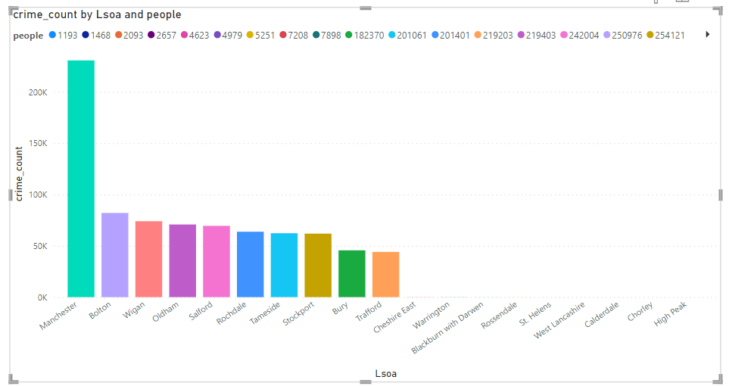

The below visualisation is crime wise number in Manchester crime type on x-axis and number of crimes on y-axis.

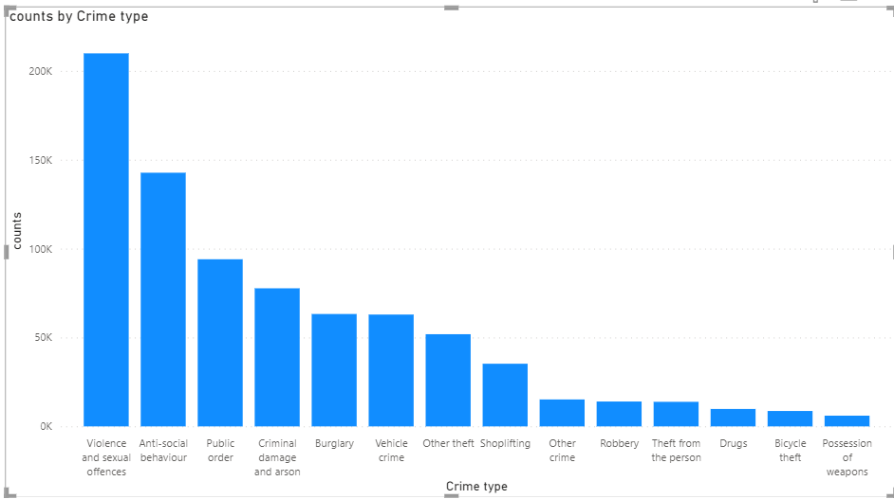

### QGIS REPORTS

The data has been analysed, we took those reports and did the plotting in QGIS to visualise the data using maps.

This image shows the anti-social behaviour crimes in Salford.

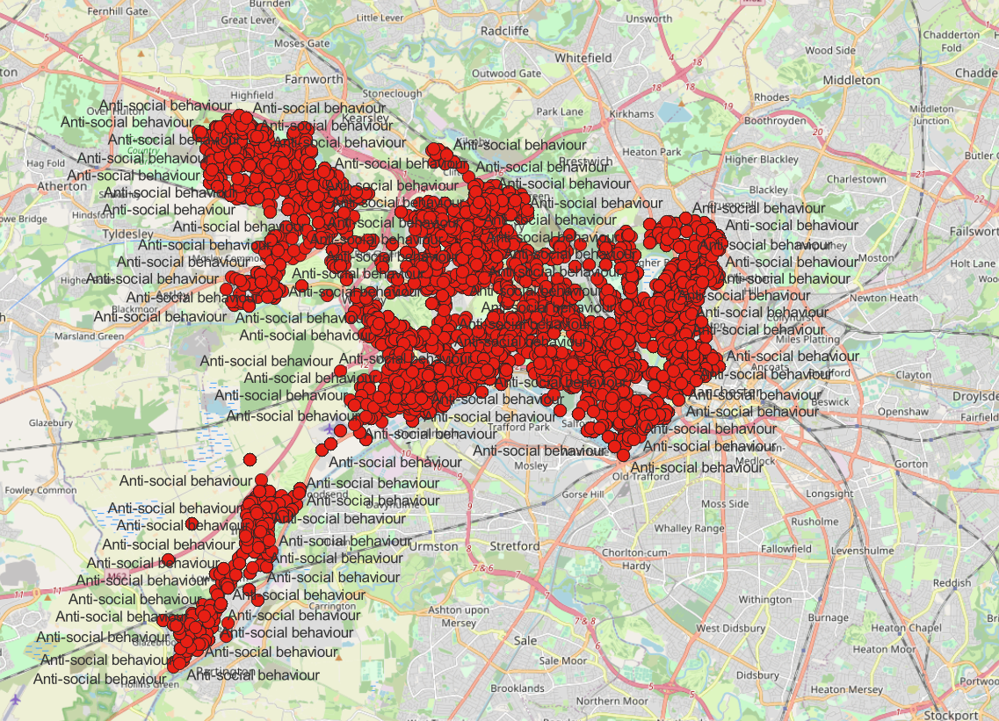

The below image displays the plotted vehicle crime numbers in Manchester.

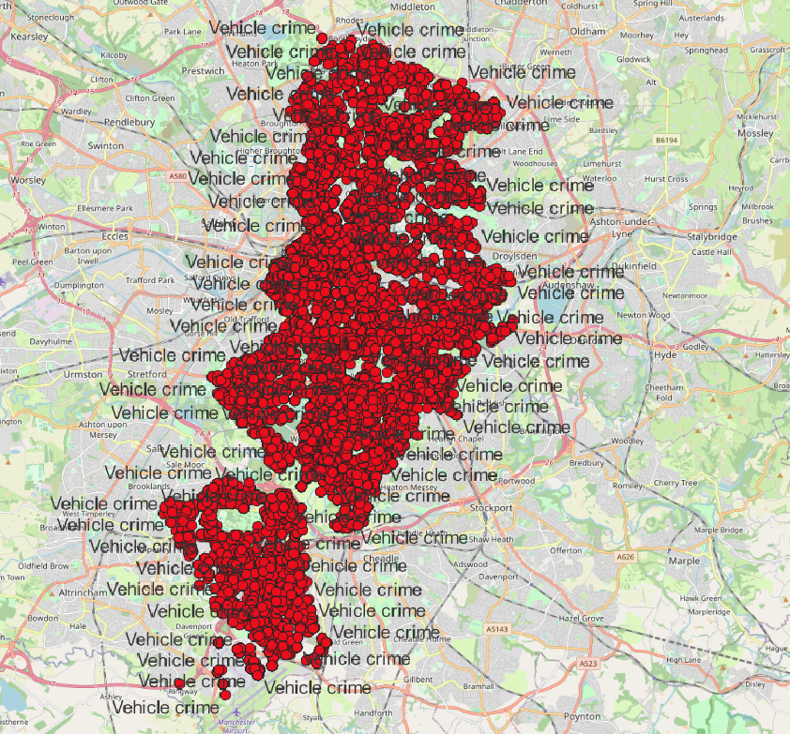

The below image shows all the plots of Burglaries happened in Bolton.

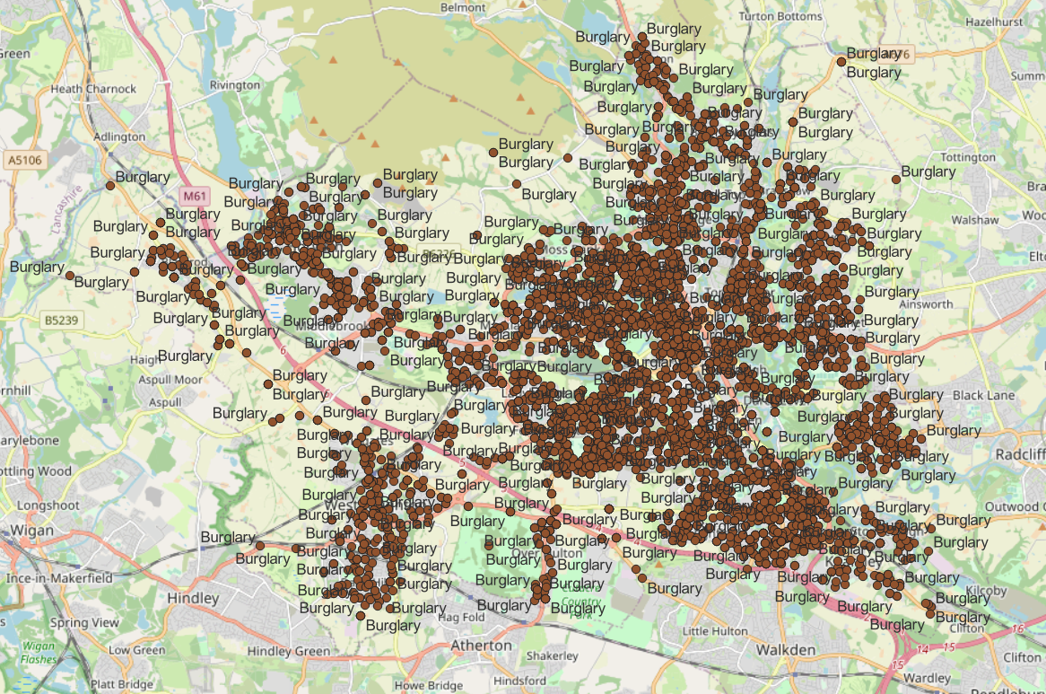

The below image shows all violence and sexual offence crimes in Wigan.

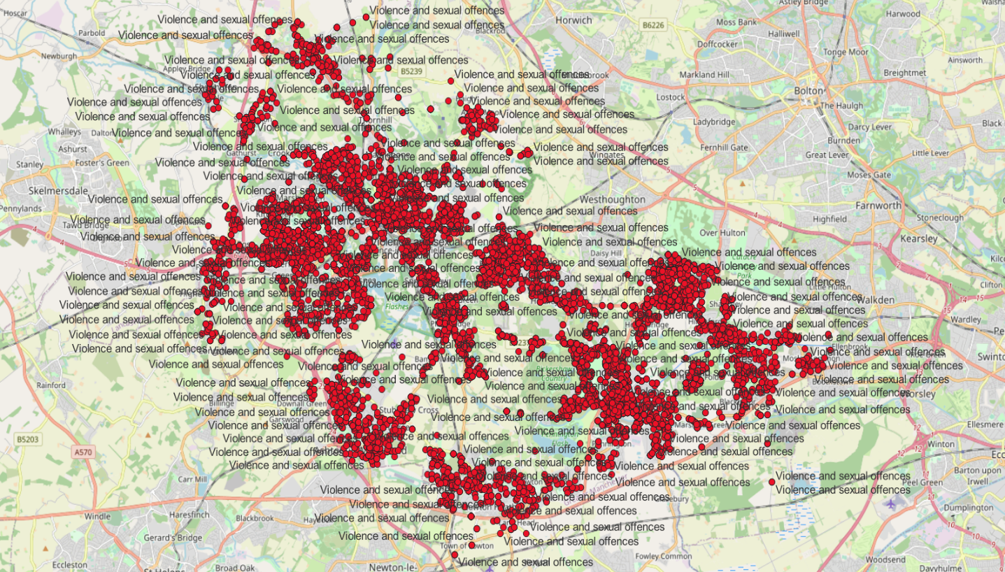

## DATA SCIENCE/BUSINESS INTELLIGENCE TECHNIQUES

In this task we used powerbi to plot the report we generated and also, we used QGIS for satellite mapping the crimes using the geolocation.

## DATA PRIVACY, ETHICAL AND LEGAL ISSUES

The data for this task we used UK police crime data and population data from UK govt website, these data must be used for study/research purposes only, misusing of the data is culpable offence.

## CONCLUSION

The analysis shows different types of crimes and their increasing numbers, and these results can be used to create a crime profile report.

# REFERENCES

UK DATA SERVICES: - <https://beta.ukdataservice.ac.uk/myaccount/login>

UNIVERSITY OF OXFORD YOUNG LIVES: - <https://www.younglives.org.uk>

UK POLICE CRIME DATA: - <https://data.police.uk/data>

UK POPULATION DATA: - <https://www.ons.gov.uk/peoplepopulationandcommunity/populationandmigration/populationestimates/datasets/lowersuperoutputareamidyearpopulationestimates>